# A PROJECT REPORT

**ON**

## “Sanjeevani Covid-19 App”

IN THE PARTIAL FULFILLMENT OF THE REQUIREMENTS FOR THE AWARD

OF

# DIPLOMA IN COMPUTER ENGINEERING

**(2020-2021)**

**BY**

## ROLL NO. NAME OF STUDENTS

6111 Mrunal Shashikant Kshirsagar

6144 Sakshi Ganesh Shendkar

6147 Kunal Gopal Kulkarni

6150 Aditya Ajay Thorat

**UNDER THE GUIDANCE OF**

**Prof. S. Y. Divekar**



**ALL INDIA SHRI SHIVAJI MEMERIAL SOCIETY’S POLYTECHNIC, PUNE 1**

**COMPUTER ENGINEERING DEPARTMENT**

**VISION AND MISSION OF THE INSTITUTE**

* **VISION:**

Achieve excellence in quality technical education by imparting knowledge, skills and abilities to build a better technocrat.

* **MISSION:**

**M1:** Empower the students by inculcating various technical and soft skills.

**M2:** Upgrade teaching-learning process and industry-institute interaction

continuously.

**VISION AND MISSION OF THE COMPUTER DEPARTMENT**

* **VISION:**

“Enhance skills by providing value based technical education for fulfilling global needs in the field of computer engineering.”

* **MISSION:**

1. To provide quality education in computer engineering by improving

psychomotor skills.

1. To develop positive attitude, communication skills, team spirit

and entrepreneurship.

1. To develop awareness about societal and ethical responsibility for

professionalism.

**PROGRAM OUTCOMES (POs)**

|  |  |
| --- | --- |
| **PO1** | **Basic knowledge:** An ability to apply knowledge of basic mathematics, science and engineering to solve the engineering problems. |
| **PO2** | **Discipline knowledge:** An ability to apply discipline - specific knowledge to solve core and/or applied engineering problems. |
| **PO3** | **Experiments and practice:** An ability to plan and perform experiments and practices and to use the results to solve engineering problems. |
| **PO4** | **Engineering Tools:** Apply appropriate technologies and tools with an understanding of the limitations. |
| **PO5** | **The engineer and society:** Demonstrate knowledge to assess societal, health, safety, legal and cultural issues and the consequent responsibilities relevant to engineering practice. |
| **PO6** | **Environment and sustainability:** Understand the impact of the engineering solutions in societal and environmental contexts, and demonstrate the knowledge and need for sustainable development. |
| **PO7** | **Ethics:** Apply ethical principles and commit to professional ethics and responsibilities and normsof the engineering practice. |
| **PO8** | **Individual and team work:** Function effectively as an individual, and as a member or leader in diverse/multidisciplinary teams. |
| **PO9** | **Communication:** An ability to communicate effectively. |
| **PO10** | **Life-long learning:** Recognize the need for, and have the preparation and ability to engage in Independent and life-long learning in the context of technological changes. |

**PROGRAM SPECIFIC OUTCOMES (PSO)**

The Diploma in Computer Engineering will prepare students to attain:

* **PSO 1:**  Apply computing knowledge with standard practices to develop software.
* **PSO 2:** Maintain Computer Hardware and Software System



### DEPARTMENT OF COMPUTER ENGINEERING

**C E R T I F I C A T E**

**This is to certify that the project report entitles**

#### “SANJEEVANI COVID-19 APP”

**Submitted by**

|  |  |
| --- | --- |
| **ROLL NO.** | **NAME OF STUDENTS** |
| **6111** | **Mrunal Shashikant Kshirsagar** |
| **6144** | **Sakshi Ganesh Shendkar** |
| **6147** | **Kunal Gopal Kulkarni** |
| **6150** | **Aditya Ajay Thorat** |

Is a bonafide work carried out by them under the supervision of **Prof. S. Y. Divekar**and it is approved for the partial fulfillment of the requirement of MSBTE for the award of the diploma in Computer Engineering.

**Prof. S. Y. Divekar** **Prof. V. N. Kukre.**

Guide Head

Department of Computer Engineering Department of Computer Engineering

**Prof. S. K. Giram**

Principal,

AISSMS’s Polytechnic, Pune – 01 External Examiner

Place : Pune Date :

## ACKNOWLEDGEMENT

With an immense pleasure and satisfaction, we presenting this Project report as part of the curriculum of Diploma Computer Engineering. We wish to express our sincere gratitude towards all those who have extended their support right from the stage this idea was conceived.

We are profoundly grateful to **Prof. S. Y. Divekar**, Project Guide, for his expert guidance and continuous encouragement throughout to see that project work right its target since its commencement to its completion.

We are thankful to **Prof. A. N. Gedam**, Project Coordinator, for conducting and supporting such research activities.

We are also grateful to **Prof. V. N. Kukre**, HOD, Department of Computer Engineering, for his support and encouragement.

Finally, we are grateful to Honorable **Prof. S. K. Giram**, Principal, AISSMS POLYTECHNIC, Pune, for his support and guidance that have helped me to expand my horizons of thought and expression and we would like to express once again our gratitude and thanks to all those who are involved directly and indirectly in making our project a success.

Signature

|  |  |
| --- | --- |
| ROLL NO. | NAME OF STUDENTS |
| 6111 | Mrunal Shashikant Kshirsagar |
| 6144 | Sakshi Ganesh Shendkar |
| 6147 | Kunal Gopal Kulkarni |
| 6150 | Aditya Ajay Thorat |

**Abstract**

To track the massive spike of the cases in this pandemic situation of corona virus or technically known as COVID-19, we decided to create an Android application. This corona virus was first discovered in China and then from there it started spreading all over the world and to track the record of the cases, deaths and recovery we decided to develop an Android application. This application was developed to spread awareness in our country (India) about this situation. This app provides the information about the COVID-19 cases, the confirmed cases, the total deaths, total recovered patients and the active cases in our country (India). This app shows the above-mentioned details of our country (India) and the foreign countries too. Even this application shows the state wise information. All the symptoms and the steps to take against the corona virus is available in the application. Red zone areas and the helpline numbers are available of all the states of India. This application provides the live information of cases in numbers. With this application the people will get aware of the situation and even they can check whether they are in the red zone area by searching in the application. The users can see the active cases, total confirmed cases, total death, total diseased people, and total people who fought against this virus and had won (recovered people) of all the states in India and even get helpline numbers of all the states. We have created this very simple and straight forward application which make it very easy to use and its UI is user friendly easy to understand. All the provided information is perfect and accurate. The information provided in the application is taken from WHO (World Health Organization).

# INDEX

|  |  |  |
| --- | --- | --- |
| **Chapter No.** | **Contents** | **Page No.** |
| 1. | Introduction | 5 |
| 2. | Literature Survey | 7 |
| 3. | Scope of Project | 9 |
| 4. | Methodology | 11 |
| 5. | Details of designs, working and processes | 16 |
| 6. | Result and Applications | 19 |
| 7. | Conclusions and future scope | 21 |
| 8. | Publications | 22 |
| 9. | References and Bibliography | 30 |

**CHAPTER 1**

**INTRODUCTION**

**____________________________________________**

1. **IDEA OF PROJECT:**

We got the idea of this project when we were reading news the increasing Corona virus and thought that it would be a great idea to develop an application which can help everyone to stay safe at home! Our guide motivated us to create application on android platform as most of smartphone users are on android platform.

**1.1 MOTIVATION OF PROJECT:**

In this pandemic situation, our covid warriors means the Doctors & Nurses are giving their best to save our lives, in the situation of lockdown Police & Army officers are doing 24 hours of duty for our safety, the Sweepers & Maids are contributing to keep hygiene around us, even social workers are coming forward to help the needy and poor people.

The above-mentioned warriors are doing their respective jobs consistently with all open-heart humanity and this is the one thing which has motivated us to do something for society by using our knowledge.

So, we got inspiration from them and thought as a future Computer Engineer to do something which will contribute a little to our society and hence developed an easy to use and flexible android application that is Covid-19 App.

**1.3 OVERVIEW:**

In this pandemic situation of contagious coronavirus, or more commonly knowns as COVID 19. First this virus was discovered in China in November 2019 and started spreading all over the world. On July, 2020, more than 17M cases of COVID-19 were reported. This COVID-19 situation is listed as the pandemic by the WHO (World Health Organisation). But along with the rise of COVID-19 cases, there are lot of applications create by lot of COVID-19 warriors. We have also created an Android application which gives information about the cases and the COVID situation to spread awareness about this pandemic situation. On January, 2020, the first case of coronavirus was discovered in India. All the corona warriors (Doctors, Nurses, Police Officers, Traffic Police Officers, Dentists, Trained Workers, etc) are fighting against this virus, so we decided to contribute from our side in this fight against corona virus. We decided to create an Android Application which can provide all the information about the active cases, total confirmed cases, total death, total diseased people, and total people who fought against this virus and had won the fight (recovered people). This app shows the above mentioned details of our country (India) and the foreign countries too. Even this application shows the state wise information. All the symptoms and the steps to take against the corona virus is available in the application even in Hindi language. Red zone areas and the helpline numbers are available of all the states of India. Our application provides the information in numbers and all the provided information is completely accurate and correct, the information is taken from the World Health organization, the US Centers for Disease Control and Prevention, National Public Radio, WHO Coronavirus, the COVID tracking project, Centers for Disease Control and Prevention, Maryland Transportation Institute (“MTI”) and several other sources. It has spread so rapidly and to so many countries that the World Health organization has declared it a pandemic (a term indicating that it has affected a large population, region, country, or continent). It’s very easy to download this application and see the live information provided in the application. This can be the easiest way to spread awareness about this pandemic situation to the people of our country. Even the people can share this application among their friends which will definitely spread awareness. More people get to know about this issue it will be easy to handle the situation.

**CHAPTER 2**

**Literature Survey**

From our curated list of 34 apps, we select four typical app to further highlight key lessons we can learn with respect to security and privacy risks. The case studies are based on Trace Together, DP3T, Private Kit, and COVID Safe. This digital system has created to provide the facilitate contact tracing efforts in response to the COVID-19 pandemic. The main purpose of this digital system or the main goal of this digital system is quick identification of persons who may have come into close contact with anyone who has tested positive for COVID-19. The system initially consisted of an app, by the same name, and was later supplemented by a physical token mainly intended for elderly and children who may not own a smartphone, or those who prefer not to use the app. The protocol, and reference app implementations of it, were also open sourced as Blue Trace and Open Trace respectively. DP3T: This DP3T (Decentralized Privacy-Preserving Proximity Tracing) is an open protocol developed in response to the COVID-19 pandemic, and was introduced on April, 4, 2020. This open protocol is created to provide or to facilitate digital contact tracing of infected participants. This is software or application is created for the Android and iOS users, they can easily download this application in their smart phones. Even DP3T is safe for using as the central reporting server never has access to contact logs nor is it responsible for processing and informing clients of contact. Because contact logs are never transmitted to third parties so, it has major privacy benefits. In contrast to Trace Together, the app does not implement any root detection capabilities. This means that a malicious app could possibly access the database directly and manipulate the database containing COVID-19 contact records. Potentially, an adversary could spread falsepositive. We didn’t want to spread a false-positive so we decided to overcome this issue. Private Kit: Similar to DP3T, Private Kit does not encrypt the database and contains plaintext data. So we decided not to include this feature and keep our users safe form these all breaches taking place. COVID Safe: According to our experiments, COVID Safe stores all tracing histories, including contacted device IDs and timestamps, into SQLite database with plain text. Since the application does not implement a root detection logic, tracing histories may be leaked from root devices and potential Linkage Attacks can be implemented. But in the later update they fixed this issue, so this was actually a good step and we decided to implement this type of feature in our application

|  |  |  |  |  |  |  |  |  |  |  |  |  |  |  |  |  |  |  |  |  |  |  |  |  |  |  |  |  |  |  |  |  |  |  |  |  |  |  |  |  |  |  |  |  |  |  |  |  |  |  |  |  |  |  |  |  |  |  |  |  |  |  |  |  |  |  |  |  |  |  |  |  |  |  |  |  |  |  |  |  |  |  |  |  |  |  |  |  |  |  |  |  |  |  |  |  |  |  |  |  |
| --- | --- | --- | --- | --- | --- | --- | --- | --- | --- | --- | --- | --- | --- | --- | --- | --- | --- | --- | --- | --- | --- | --- | --- | --- | --- | --- | --- | --- | --- | --- | --- | --- | --- | --- | --- | --- | --- | --- | --- | --- | --- | --- | --- | --- | --- | --- | --- | --- | --- | --- | --- | --- | --- | --- | --- | --- | --- | --- | --- | --- | --- | --- | --- | --- | --- | --- | --- | --- | --- | --- | --- | --- | --- | --- | --- | --- | --- | --- | --- | --- | --- | --- | --- | --- | --- | --- | --- | --- | --- | --- | --- | --- | --- | --- | --- | --- | --- | --- | --- | --- |
| **CHAPTER 3**  **Scope of the project**  __________________________________________________________  **3.1 PROBLEM DEFINITION AND SCOPE OF THE PROJECT:**  **3.1.1 PROBLEM DEFINITION:**  **PURPOSE AND SCOPE OF DOCUMENT:** The rapidly evolving nature and severity of the covid-19 pandemics, new approaches towards safety, risk mitigation, to stop the spread, to let everyone not get mislead by knowing the fake count of patients, to get over the language barrier and last to reduce the health system burden.  **Overview of responsibilities of Developer**  The team comprises of 4 members for development of the product. We all have different sets of knowledge, experiences regarding latest technologies and languages.  1. Mrunal Kshirsagar: Technical planning and coding, Documentation  2. Kunal Kulkarni: Technical planning and coding, Documentation  3. Sakshi Shendkar: Documentation, coding and most of the non-technical work   4. Aditya Thorat: Non-Technical planning and coding, Documentation At this COVID-19 pandemic situation, a application is highly important. To take it a bit further, if a business’s application is superlative in its features and navigation, customers are more inclined to trust the business and avail of their services. There is less possibility that without the application one as individual might not get the correct information about the COVID-19 situation. So with the help of this application a user can get all the important and accurate information related to COVID-19 pandemic. By using the application, one can stop the rise of COVID-19 by using the available information in the application, and achieve its objectives much faster.  **3.2 SCOPE OF THE PROJECT:**  Covid-19 has become an international emergency. The use of our Sanjeevani App can be effective in managing, preventing, and overcoming the further spread of infectious disease outbreaks. Accordingly, the use of Mobile health technologies has the potential to promote public health. This project aimed for managing the current pandemic situations in an effective manner. Includes flexible sharing and straightforward handling for new users. It is accessible for any kind of contagious disease  **3.3Resource Requirements**:  **Software Specifications**   |  |  |  | | --- | --- | --- | | **Sr. No.** | **Resource** | **Configuration** | | 1. | Operating System | Windows 10 | | 2. | Coding Language | Java | | 3. | Software | Android studio 4.1 |   **Hardware Specifications**   |  |  |  | | --- | --- | --- | | **Sr. No** | **Resource** | **Configuration** | | 1 | Processor | Intel i3 core | | 2 | Speed | 2.5 GHz | | 3 | RAM | 4 GB | | 4 | Hard Disk | 8 GB | | 5 | Key Board | Standard Windows Keyboard | | 6 | Mouse | Two or Three Button Mouse | | 7 | Monitor | SVGA |   **OUTCOME:**   * Provides information about this pandemic situation of COVID 19 like the confirmed case, active case, patients discharged and total deaths in our country and even it provides the information of all the states. * Combats the second and third waves of the COVID-19 by providing accurate aggregated data to help inform policy decisions. * Provides accurate and updated information of the no. patients all over the world. * Helpline numbers can be quickly accessed. * It can easily and quickly be deployed for all future pandemics and epidemics. * Improved efficiency   **CHAPTER 4**  **Methodology**  **__________________________________________________________**  **4.0 PROJECT PLAN:**  **4.1 PROJECT ESTIMATES:**  The estimation of project can be carried out depending upon the feasibility study of all the service (i.e. modules) which is included in our project. The numbers of automation tools, Function points are used for calculations of estimate. Since with the feasibility study for our project, it can be designed and developed within 7-8 months. The different stages like communication, planning, modelling, construction and deployment of waterfall model are used at every stage.  **Reconciled Estimates**  **•** Requirement analysis requires 2months.  • Literature Survey requires 1 month.  • Feasibility study and analysis requires 1 month.  • Implements and testing requires 3 months.  • Deployment requires 1 month.  **COST ESTIMATE:**  Cost of a project is estimated using current estimation models such as automation tools which allow us to estimate cost as a function of size. Thus, it also allows us to estimate and analyze the feasibility of competition of the system in given time frame. As this project is developed completely using software applications, the expenditure during development are only the efforts made by the developer for the successful completion of the project.  **TIME ESTIMATES**: Since with the feasibility study for our project, it can be designed and developed within 7-8 months. The different stages like communication, planning, modeling, construction and deployment of waterfall model are used at every stage.  **Project Plan:**   |  |  |  | | --- | --- | --- | | **Sr. No.** | **Duration** | **Tasks** | | 1. | 1-7-2020 to 14-7-2020 | Domain selection | | 2. | 15-7-2020 to 18-7-2020 | Topic selection | | 3. | 18-7-2020 to 28-7-2020 | Base paper submission | | 4. | 17-8-2020 to 31-8-2020 | Literature survey | | 5. | 1-9-2020 to 16-9-2020 | Requirement collection | | 6. | 20-9-2020 to 5-10-2020 | Modeling | | 7. | 6-10-2020 to 10-10-2020 | Designing | | 8. | 12-10-2020 | 50% construction | | 9. | 3-12-2020 to 20-12-2020 | 1st demo of project | | 10. | 10-1-2021 to 20-1-2021 | 70% construction | | 11. | 14-2-2021 | Final demo to guide | | 12. | 5-3-2021 | Report |   Design is multi-step process that focuses on data structure software architecture, procedural details, (algorithms etc.) and interface between modules.   |  |  |  |  | | --- | --- | --- | --- | | **Sr. No.** | **Task** | **Start Date** | **End Date** | | 1. | Requirement Gathering | 17-8-2020 | 31-8-2020 | | 2. | Planning | 1-9-2020 | 8-9-2020 | | 3. | System Designing | 10-9-2020 | 16-9-2020 | | 4. | Implementation | 6-10-2020 | 20-12-2021 | | 5. | Documentation | 10-2-2021 | 3-2-2021 |   **4.2 SOFTWARE TESTING:**  **Manual Test:**  Manual and Automated test are the types of software testing. We are doing a manual test for testing our system that is without using any automated tool or any script. In this type tester takes over the role of an end user and test the software to identify any unexpected behavior or bug. There are different stages for manual testing like unit testing, integration testing, system testing and user acceptance testing. Testers use test plan, test cases or test scenario to test the software to ensure the completeness of a testing. Manual testing also includes exploratory testing as a testers explore the software to identify the errors in it.  **Automated Test:**  Automation testing which is also known as Test Automation is when the tester writes scripts and  uses software to test the software. This process involves automation of a manual process. Automation Testing is used to re-run the test scenarios that were performed manually, quickly and repeatedly.  **1)White Box Testing**  Sometimes called glass-box testing is a test case design method that uses the control structure of  the procedural design to derive test cases. Using white-box testing methods, the software engineer can derive test cases that  (1) Guarantee that all independent paths within a module have been exercised at least once,  (2) Exercise all logical decisions on their true and false sides,  (3) Execute all loops at their boundaries and within their operational bounds, and  (4) Exercise internal data structures to ensure their validity.  White-box testing of software is predicated on close examination of procedural detail by unit and integration testing. Providing test cases that exercise specific sets of conditions and/or loops tests logical paths through the software. The status of the program may be examined at various points to determine if the expected or asserted status corresponds to the actual status. Basis path testing is a white-box testing technique first proposed by Tom McCabe. The basis path method enables the test case designer to derive a logical complexity measure of a procedural design and use this measure as a guide for defining a basis set of execution paths. Test cases derived to exercise the basis set are guaranteed to execute every statement in the program at least one time during testing. In this system, the system was tested for the calculation matters were the data provided for giving the right output or not. If wrong data was provided then what it is throwing error or accepting.  **2)Black Box Testing**  Also called behavioral testing, focuses on the functional requirements of the software. That is, black box testing enables the software engineer to derive sets of input conditions that will fully exercise all functional requirements for a program. Black box testing is not an alternative to white-box techniques. Rather, it is a complementary approach that is likely to uncover a different class of error than white-box methods. When computer software is considered, black box testing Alludes to tests that are conducted at the software interface. Although they are designed to uncover errors, black-box tests are used to demonstrate that software functions are operational, that input is properly accepted and output is correctly produced and that the integrity of external information is maintained. A black-box test examines some fundamental aspect of a system with a little regard for the internal logical structure of the software. Black-box testing attempts to find errors in the following categories:  6. Incorrect or missing functions  7. Interface errors  8. Errors in data structures or external database access  9. Behavior or performance errors  10. Initialization and termination errors  By applying back-box techniques, a set of test cases that satisfy the following criteria are derived:  Test cases that reduce, by a count that is greater than one, the number of additional test cases that  must be designed to achieve reasonable testing. Test cases that tell us something about the presence or absence of classes of errors, rather than an error associated only with the specific test at hand.  White-box testing should not, however, be dismissed as impractical. A limited number of important logical paths can be selected and exercised. Important data structures can be probed for validity. The attributes of both black and white box testing can be combined to provide an approach that validates the software interface and selectively ensures that the internal workings of the software are correct. Black box testing for this system was done to check the internal testing i.e., the system is working properly in each case or no. What kind of errors are there in database design. To find out faults, mistakes there is use of different black box testing methods like system testing, performance testing, load testing, etc.  **3)System testing**  System testing is testing the whole system. It follows the scope of black box testing which doesn’t require any knowledge of design of code or logic. It performs to test the fulfillment of functional requirement specification (FRS) and software requirement specification (SRS). It tests about graphical user interface, usability, performance, compatibility, exception handling, load, volume, stress, security, accessibility, failure and recovery etc.  **4)Performance testing**  Any software should be a quality software and quality measures by using the attributes reliability, scalability and resource usage. Performance testing is the general testing which determine how system performs? This is in terms of responsiveness and stability under maximum workload. Proposed system gives positive response to performance testing. It works properly and give proper output for large number of database. Resource usage is also maximum. The only thing is for very large amount of database system performance i.e computation time of system get increased.  **5)** **Beta testing**:  Beta testing is an opportunity for real users to use a product in a production environment to uncover any bugs or issues before a general release. Beta testing is the final round of testing before releasing a product to a wide audience. The objective is to uncover as many bugs or usability issues as possible in this controlled setting. Beta testers are “real” users and conduct their testing in a production environment running on the same hardware, networks, etc., as the final release. This also means it’s the first chance for full security and reliability testing because those tests can’t be conducted in a lab or stage environment. Beta tests can either be open or closed. In an open test, anyone can use the product and is usually presented with some messaging that the product is in beta and given a method for submitting feedback. In closed beta, the testing is limited to a specific set of testers, which may be composed of current customers, early adopters, and/or paid beta testers. Sometimes they are conducted by diverting a certain percentage of users to the beta site instead of the current release. CHAPTER5 **Details of designs, working and processes**  **_______________________________________________________** |  |
|  |  |

**5.0 DIAGRAM (overall working):**

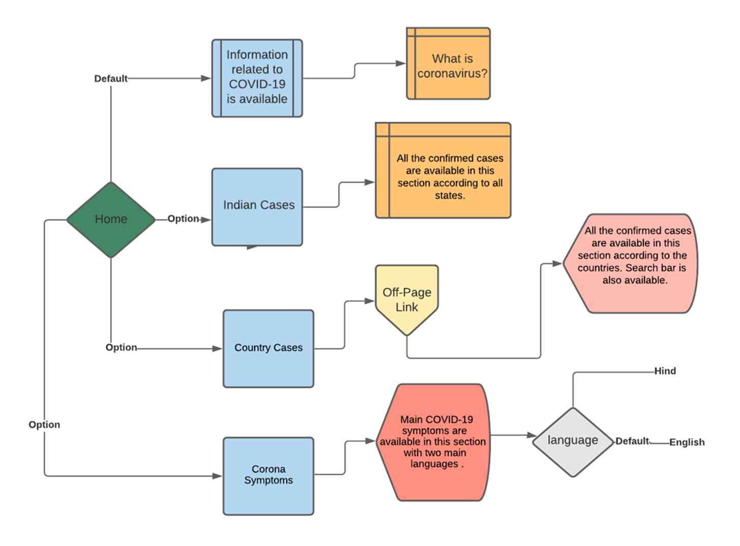

**5.1 DIAGRAM (overall Information):**

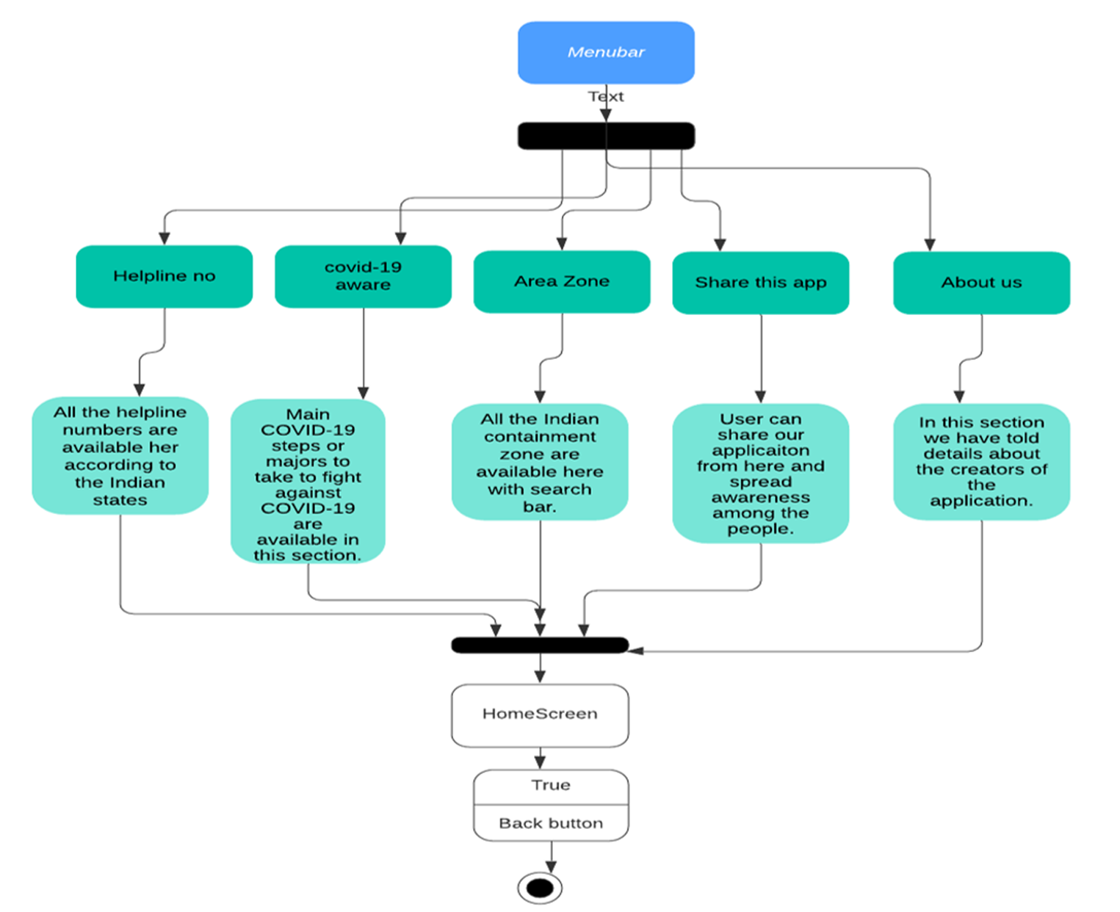

Architectural Diagram

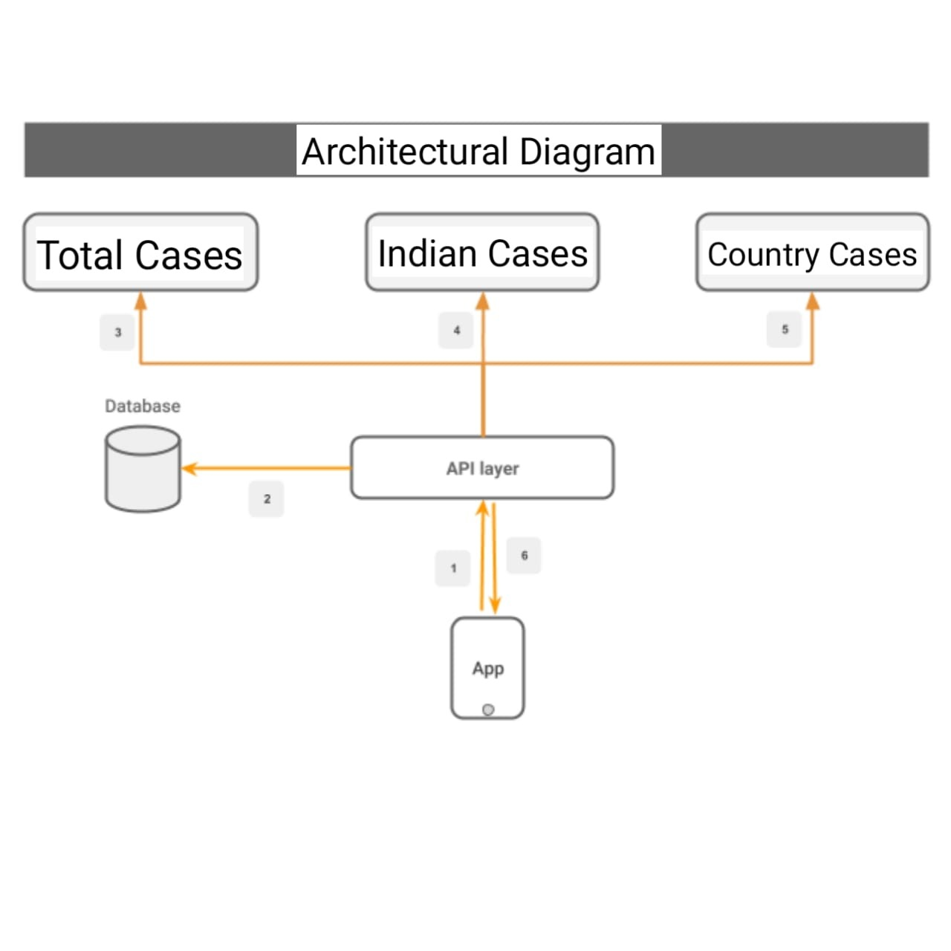

**CHAPTER 6**

**Results of The Projects**

**­­­­­­­­­­­­­­­­­­­­­­­­­­­­­­­­­­­­–––––––––––––––––––––––––––––––––––––––––––––––––––––––**

**6.0 Snapshots:**

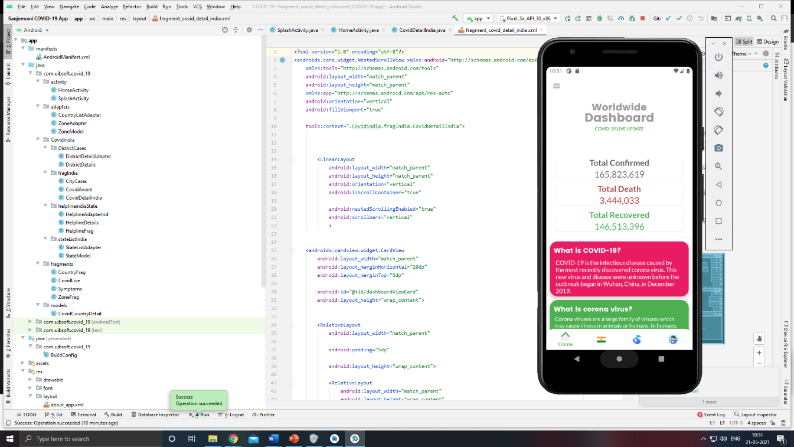

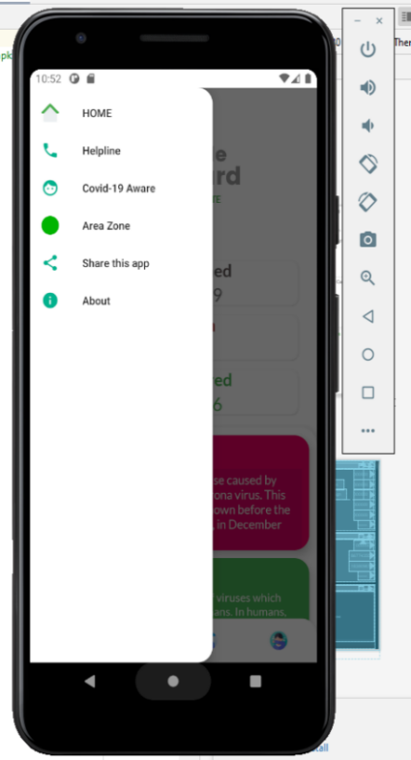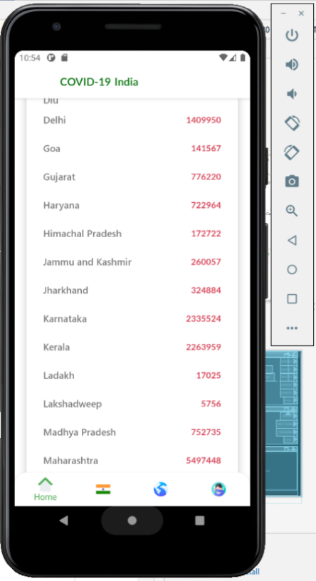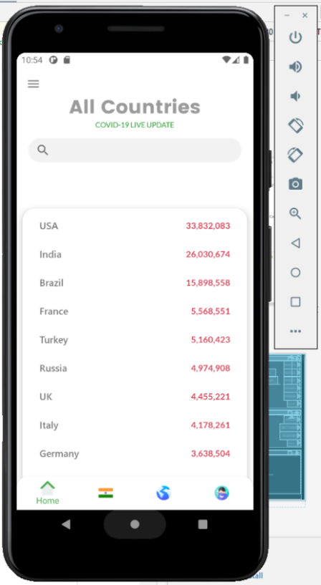

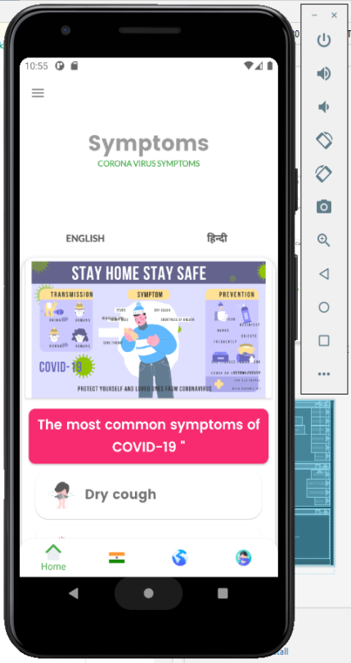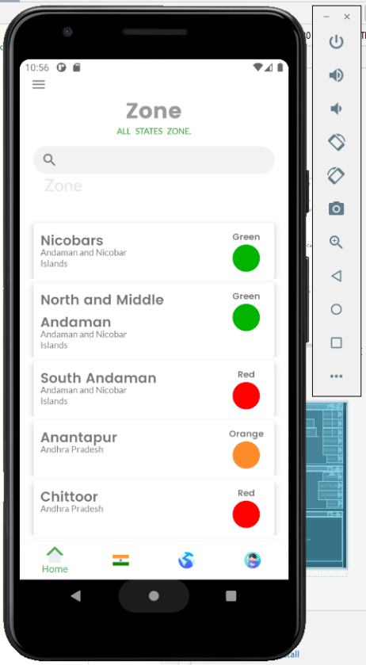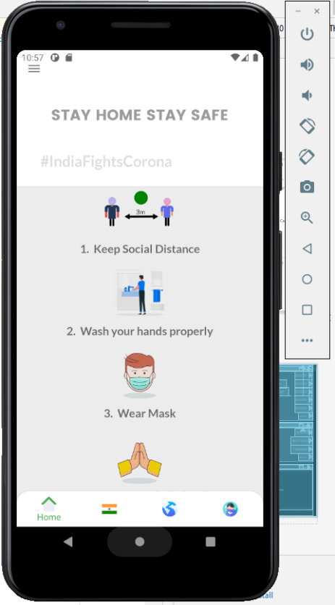

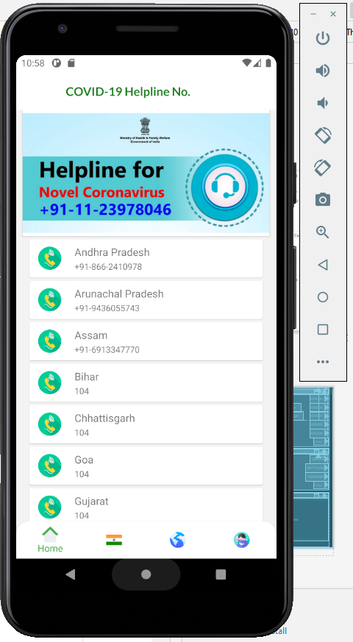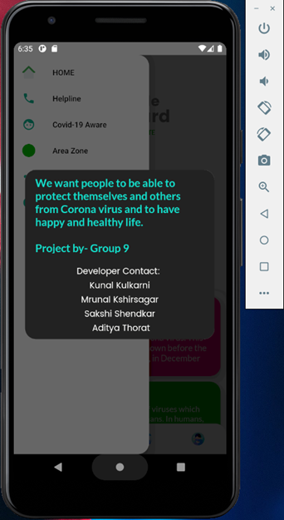

**CHAPTER 7**

**Conclusion and Future Scope**

**­­­­­­­­­­­­­­­­­­­­­_______________________________________________________________________**

**7.0 CONCLUSION:**

From this study we conclude that Mobile apps are considered to be a valuable tool for citizens, health professionals, and decision makers in facing critical challenges imposed by the pandemic, such as reducing the burden on hospitals, providing access to credible information, tracking the symptoms and mental health of individuals, and discovering new predictors. And spreading awareness among the people through a simplest possible way, not only the people get aware of this pandemic situation of COVID-19, they also get lot of information about the situation around them. As this application provides the information of active cases, total confirmed cases, total death, total diseased people, and total people who fought against this virus. All the helpline numbers are also provided in this application according to the states. It can also be concluded that it is a promising application that can help people to be safe from coronavirus. The application has useful features and impressive architecture. Even the user interface (UI) is beautiful that user-interactivity was properly kept in mind during the development of the application. So as overall, this application is complete pack of all the important information needed for an individual user.

**FUTURE SCOPE**

* The goal of application is to spread awareness among the people.
* So, this application can be used in future by changing the data for various diseases that may occur in future.
* The life of application is immense as it is based on Android.
* Includes flexible sharing and straightforward handling for new users.
* Can be accessible for any kind of contagious disease.

**CHAPTER 8**

**Publication**

**_______________________________________________________**

**8.0)**

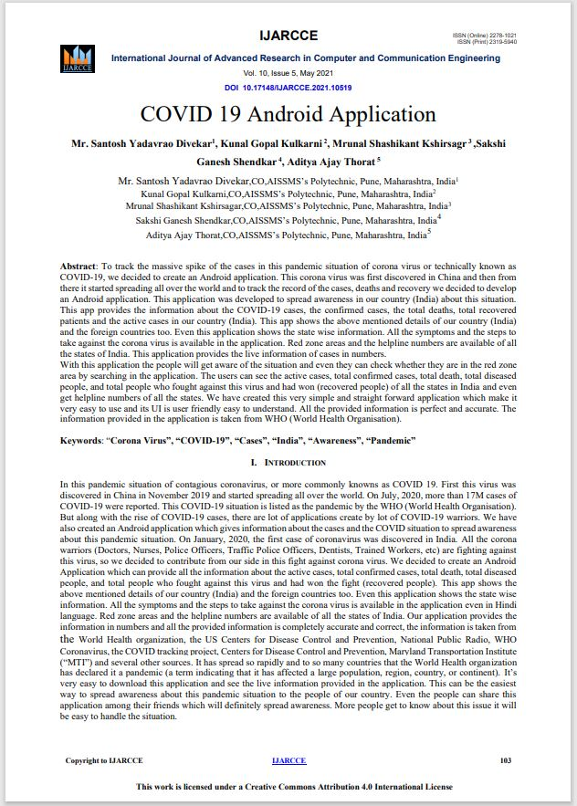

**8.1)**

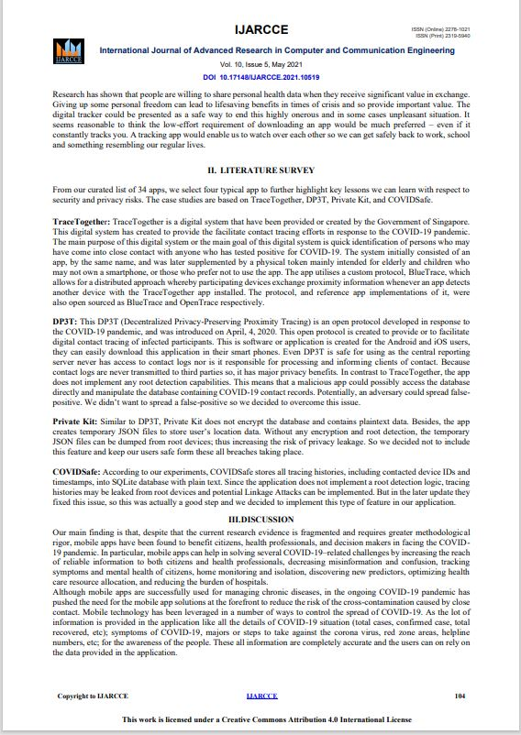

**8.3)**

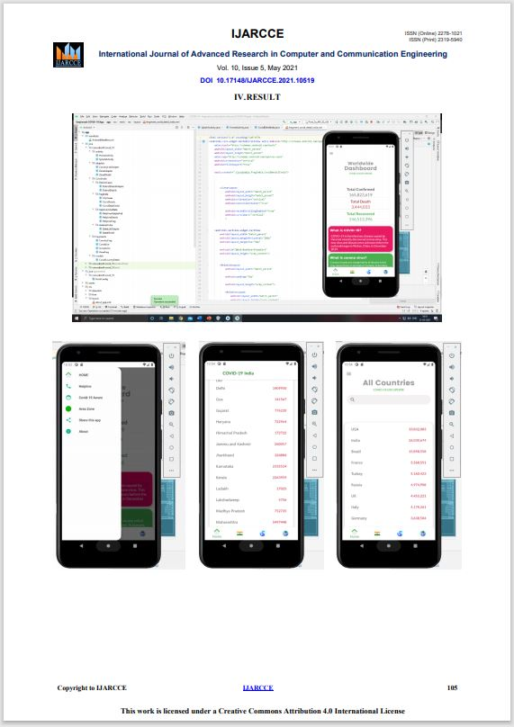

**8.4)**

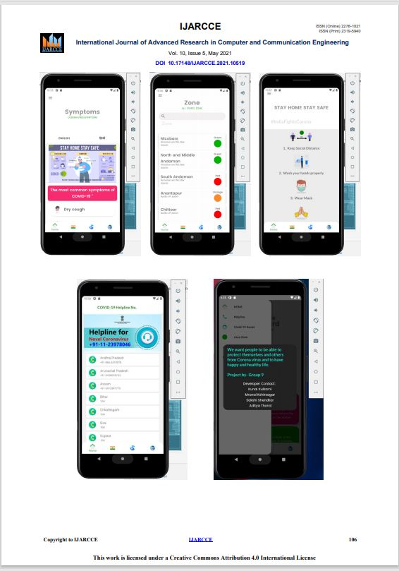

**8.5)**

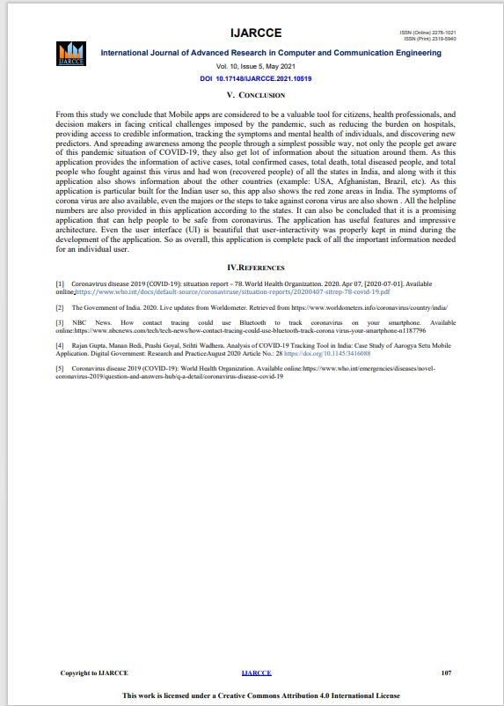

**Certificates**

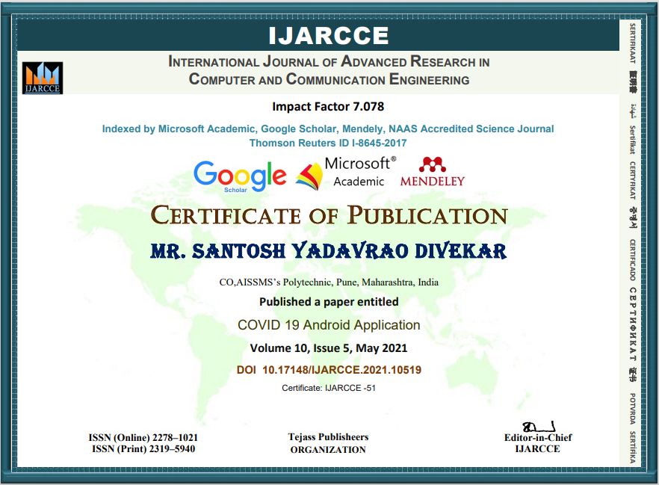

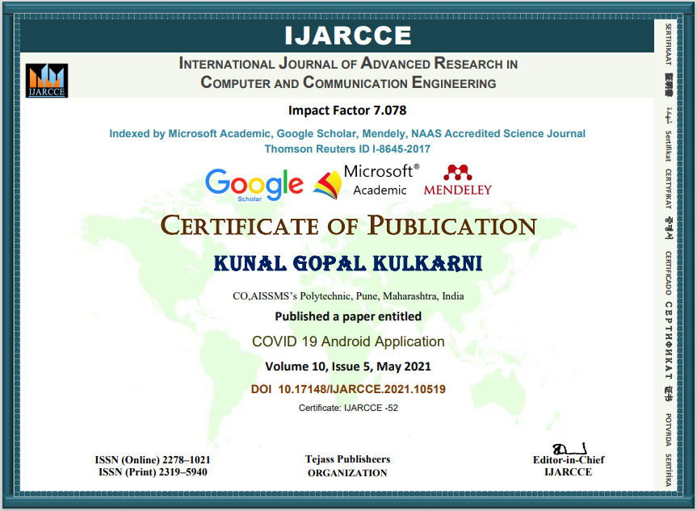

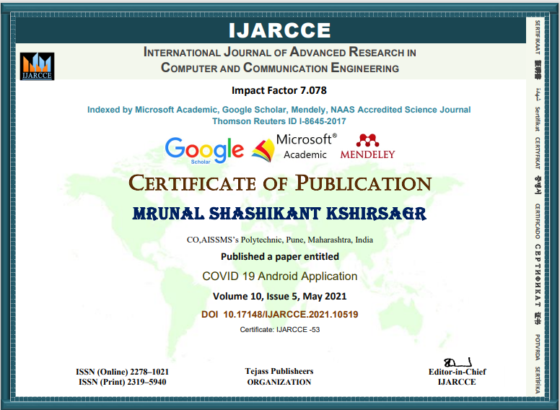

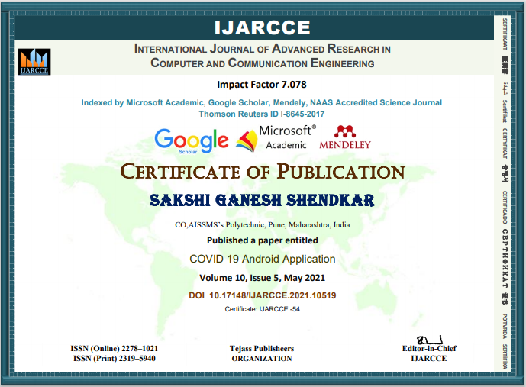

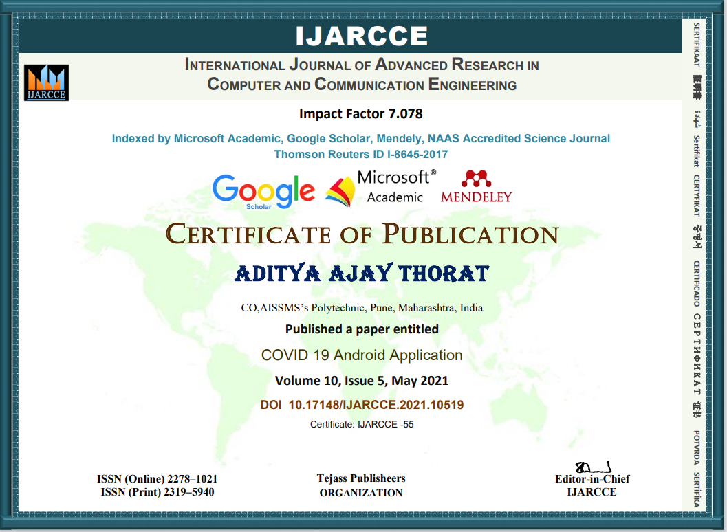

**CHAPTER 9**

**References and Bibliography**

**____________________________________________________**

**9.0 References:**

1. Coronavirus disease 2019 (COVID-19): situation report – 78. World Health Organization. 2020. Apr 07, [2020-07-01]. Available online:<https://www.who.int/docs/default-source/coronaviruse/situation-reports/20200407-sitrep-78-covid-19.pdf>
2. The Government of India. 2020. Live updates from Worldometer. Retrieved from <https://www.worldometers.info/coronavirus/country/india/>
3. NBC News. How contact tracing could use Bluetooth to track coronavirus on your smartphone. Available online:[https://www.nbcnews.com/tech/tech-news/how-contact-tracing-could-use-bluetooth-track-corona virus-your-smartphone-n1187796](https://www.nbcnews.com/tech/tech-news/how-contact-tracing-could-use-bluetooth-track-corona%20virus-your-smartphone-n1187796)
4. Rajan Gupta, Manan Bedi, Prashi Goyal, Srihti Wadhera. Analysis of COVID-19 Tracking Tool in India: Case Study of Aarogya Setu Mobile Application. [Digital Government: Research and Practice](https://dl.acm.org/journal/dgov)August 2020 Article No.: 28 <https://doi.org/10.1145/3416088>
5. Coronavirus disease 2019 (COVID-19): World Health Organization. Available online:<https://www.who.int/emergencies/diseases/novel-coronavirus-2019/question-and-answers-hub/q-a-detail/coronavirus-disease-covid-19>
6. Paper Publish Link - <https://ijarcce.com/wp-content/uploads/2021/05/IJARCCE.2021.10519.pdf>